[HOSPITAL OR FACILITY NAME]
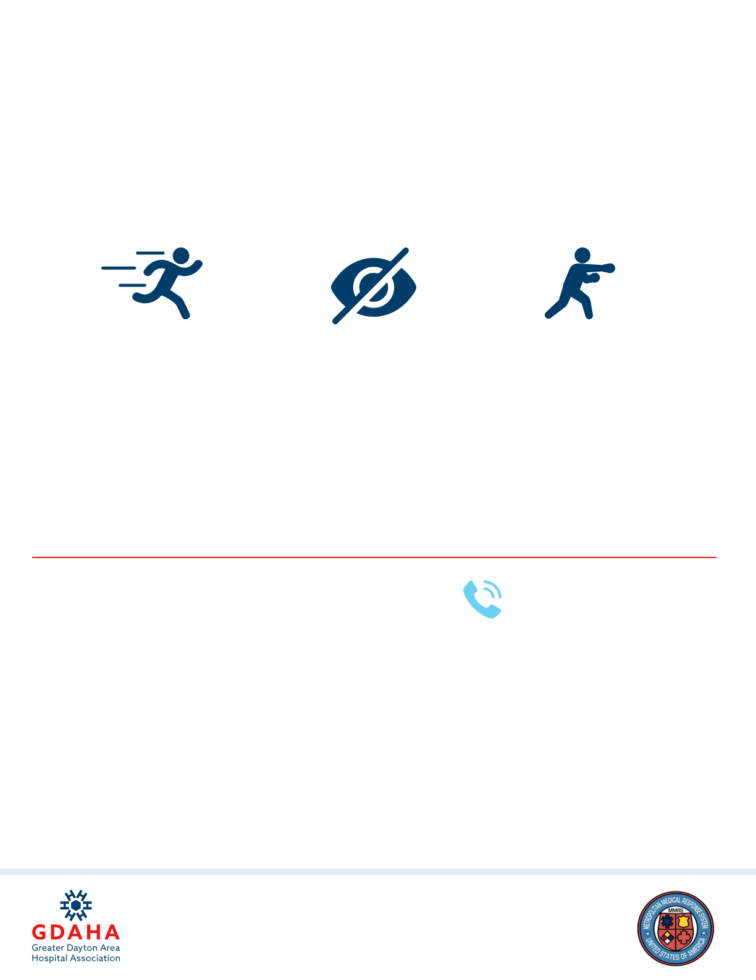
ACTIVE SHOOTER RESPONSE
RESPOND
COMMUNICATE
RUN
HIDE
FIGHT
- Provide guidance and care for patients and others
- Try to secure all critical areas
- If patients can’t be moved, try to block entry
- You have the power to protect
- Notify Hospital Security: XXX.XXX.XXXX
- Call 911
- Report location and description of shooter
- Report location and condition of patients
- Warn others!

